SIMATS Engineering
Course Name: Internet Programming
Course Code: CSA43
Name: N Jaswanth kumar
Reg No:192372324
Question 1: HTTP Response Analysis
Given HTTP response:
HTTP/1.1 200 OK
Date: Mon, 01 Apr 2026 10:00:00 GMT
Content-Type: text/html
Content-Length: -150
Connection: keep-alive
1. Identify incorrect or invalid fields
Answer:
- Content-Length: -150 is invalid because content length cannot be negative.
- The date and time should follow the correct HTTP date format. The weekday and date shown should also be checked for consistency.
- Content-Type: text/html is valid.
- Connection: keep-alive is valid for HTTP/1.1.
- HTTP/1.1 200 OK means the request was successful, but it does not guarantee that every header is correct.
2. Analyze the Content-Length issue
Answer:
The Content-Length header specifies the size of the response body in bytes. A value of -150 is invalid because the body size cannot be negative.
Impact:
- The response may be rejected by strict HTTP software.
- The server or client may handle the response incorrectly.
- It can cause parsing errors or interoperability problems.
3. Does the status code match the response correctness?
Answer:
200 OK indicates that the request was successfully processed. However, the invalid Content-Length makes the response header malformed. Therefore, the status code alone does not guarantee that the entire response is correct.
4. Suggest corrections
Answer:
Replace -150 with the actual response body length in bytes, such as 150, only if the body really contains 150 bytes. Correct the date if necessary and keep the valid headers.
Question 2: DOM Structure Analysis
Given HTML:
<html>
<head>
<title>TestPage</title>
</head>
<body>
<div>
<p>HelloWorld
</div>
</body>
</html>
1. Identify missing or improperly closed elements
Answer:
- The <p> element is missing its closing </p> tag.
- The <div> closes before the paragraph is explicitly closed.
- The document's overall structure needs correction for clear, valid HTML.
2. How will the browser interpret this structure?
The browser will attempt to repair the malformed HTML automatically. When it encounters </div>, it can implicitly close the open paragraph. Therefore, the text may still appear on the page.
3. Impact on rendering and layout
- The text may display correctly despite the error.
- The browser may repair the DOM automatically.
- Improper nesting can cause inconsistent results and make styling or JavaScript behavior harder to predict.
4. Corrected HTML
<html>
<head>
<title>TestPage</title>
</head>
<body>
<div>
<p>HelloWorld</p>
</div>
</body>
</html>
Picture 2: Correct DOM structure
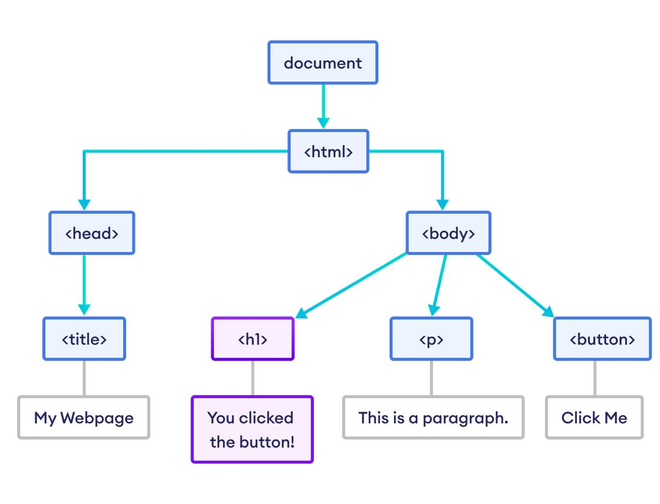
Question 3: GET vs POST in Login System
Given table from your assignment:
Method | URL example | Data visibility | Security level
GET | /login?user=admin&pass=1234 | Visible in URL | Low
POST | /login | Hidden in body | Moderate
1. Differences in data transmission
GET: Sends data as part of the URL. The data may appear in browser history, server logs and other records.
POST: Sends data in the request body rather than the URL. This avoids exposing credentials directly in the URL, but the body is not automatically encrypted.
2. Which method is more suitable for login?
Answer: POST is more suitable because it does not place usernames and passwords directly in the URL. It is commonly used for submitting login forms.
3. Security risks of GET
- Passwords may appear in browser history.
- URLs may be recorded in server logs.
- Sensitive information may be shared through copied URLs.
- Credentials may be exposed through other systems that record URLs.
4. Best practices for secure login
- Use POST for login submissions.
- Use HTTPS to encrypt data during transmission.
- Store passwords securely using a suitable password-hashing algorithm.
- Validate user input on the server.
- Use secure session management and appropriate cookie settings.
Picture 3: GET vs POST
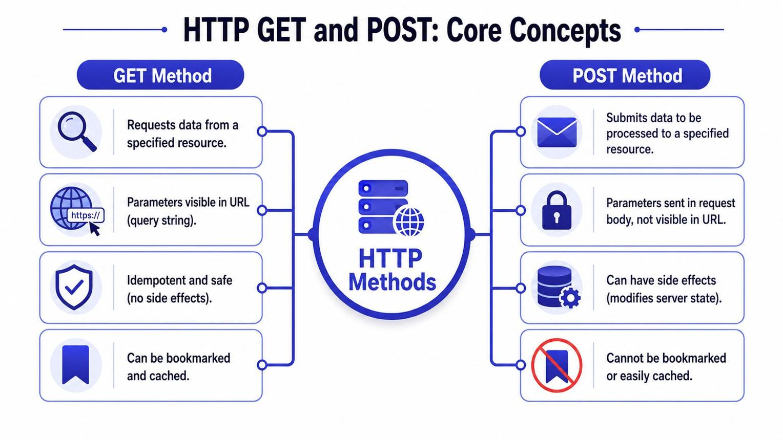

Question 4: HTML Code Inspection
Given code:
<!DOCTYPE html>
<html>
<head>
<title>Sample</title>
</head>
<body>
<h1>Welcome
<p>This is a paragraph
<img src="image.jpg">
</body>
</html>
1. Identify missing closing tags
Answer:
- </h1> is missing.
- </p> is missing.
- The <img> element does not require a closing tag in HTML5.
2. Analyze issues with the <img> tag
Answer:
The image tag should include an alt attribute to provide alternative text for accessibility. The image file image.jpg must also exist at the specified location to display correctly.
3. How will browsers handle these errors?
Browsers often automatically close missing HTML tags and attempt to render the page. However, missing tags can make the document structure less clear, and a missing image file will result in the image not displaying.
4. Corrected HTML
<!DOCTYPE html>
<html>
<head>
<title>Sample</title>
</head>
<body>
<h1>Welcome</h1>
<p>This is a paragraph</p>
<img src="image.jpg" alt="Sample image">
</body>
</html>
Picture 4: HTML code correction


Question 5: Browser–Server Communication Flow
The assignment gives this sequence:
- User enters a URL in the browser.
- DNS lookup occurs.
- HTTP request is sent.
- Server processes request.
- Response is returned.
- Browser renders page.
1. Explain each step
Step 1 — User enters a URL: The user types a website address, such as www.example.com, into the browser.
Step 2 — DNS lookup: DNS translates the domain name into an IP address so the browser can locate the server.
Step 3 — HTTP request: The browser sends an HTTP request to the server. For HTTPS, the connection is protected using TLS.
Step 4 — Server processes request: The server receives the request, runs the required processing and obtains the requested content.
Step 5 — Response is returned: The server sends an HTTP response containing a status code, headers and, usually, a response body.
Step 6 — Browser renders page: The browser processes the HTML, CSS and JavaScript to display the website.
2. Where can delays occur?
- DNS lookup may take time.
- A slow network can delay sending the request.
- Server processing may take time.
- Large files can increase download time.
- Complex HTML, CSS and JavaScript can delay rendering.
3. Role of DNS
DNS stands for Domain Name System. It translates human-readable domain names into IP addresses, allowing the browser to find the correct server.
4. Suggest optimizations
- Use DNS caching.
- Use a content delivery network (CDN).
- Compress files and images.
- Reduce unnecessary HTTP requests.
- Optimize server processing.
- Use browser caching and efficient CSS and JavaScript.
Picture 5: Browser–server communication
